**Task No. 1:**  Write the classes below containing the given instance variables and methods, following the inherited hierarchy:

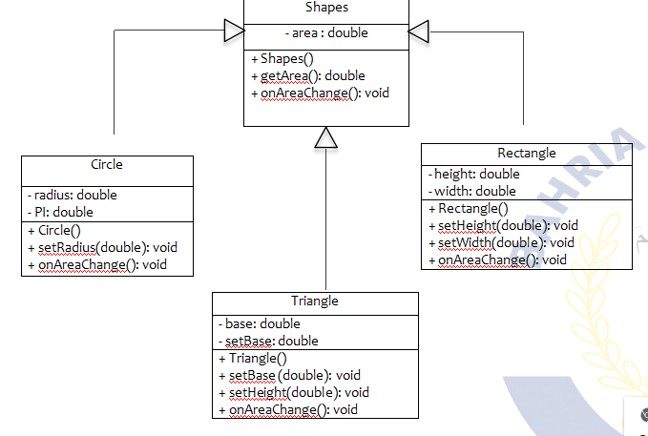

Solution:

Main Method:

package com.mycompany.mavenproject14;

public class Mavenproject14 {

public static void main(String[] args) {

System.out.println(" Area of Circle ");

Circle c1 = new Circle();

c1.setradius(4.2);

c1.areaonchange();

System.out.println(" Area of Rectangular ");

Rectangular r1 = new Rectangular();

r1.setheight(20);

r1.setwidth(19);

r1.areaonchange();

System.out.println(" Area of Triangle ");

Triangle t1 = new Triangle();

t1.setbase(23);

t1.setheight(40);

t1.areaonchange(); } }

Class Of Shapes:

package com.mycompany.mavenproject14;

public class Shapes {

double area;

public Shapes() {

area = 0; }

public double getarea(double area)

{ this.area = area;

return area; }

public void areaonchange() {

System.out.println("area is = "+area); }

}

Child Class (Circle):

package com.mycompany.mavenproject14;

public class Circle extends Shapes {

private double radius;

private double pi;

public Circle(){

radius = 0;

pi = 3.142;

}

public void setradius(double radius){

this.radius = radius;

}

public double getradius(){

return radius;

}

public void areaonchange(){

System.out.println("radius = "+radius);

area = pi * (radius* radius);

super.areaonchange();

}

}

Child Class (Triangle):

package com.mycompany.mavenproject14;

public class Triangle extends Shapes {

private double base;

private double height;

public Triangle() {

base= 0;

height=0; }

public void setbase(double base) {

this.base = base; }

public void setheight(double height) {

this.height = height; }

public double getbase() {

return base; }

public double getheight() {

return height; }

public void areaonchange() {

System.out.println("Base = "+base);

System.out.println("Hieght = "+height);

area = 0.5 *height*base;

super.areaonchange(); }

}

Child Class (Rectangle):

package com.mycompany.mavenproject14;

public class Rectangular extends Shapes {

private double height;

private double width;

public Rectangular(){

height = 0;

width = 0;

}

public void setheight(double height){

this.height = height;

}

public double getheight(){

return height;

}

public void setwidth(double width){

this.width = width;

}

public double getwidth(){

return width;

}

public void areaonchange(){

System.out.println("Height is = "+height);

System.out.println("Width is = "+width);

area = height*width;

super.areaonchange();

}

}

Output:

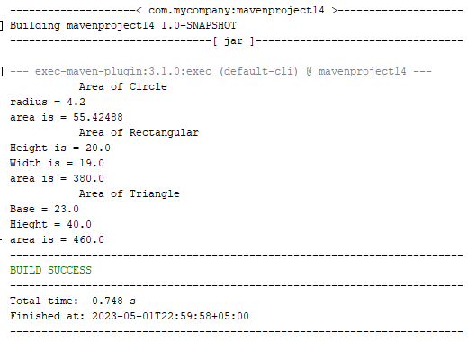

**Task No. 2:**  Write a program that inherits a class named Alien and Pirates from a parent class Human. The human class has its own features like, Human can sleep, walk, talk etc. the Alien and Pirates class inheriting these functionalities as well as they have their characteristics, thus explaining the concepts of inheritance.

**Solution:**

**Main Method:**

package com.mycompany.mavenproject33;

public class Mavenproject33 {

public static void main(String[] args) {

Human human = new Human("John");

human.sleep();

human.walk();

human.talk();

Alien alien = new Alien("Zorg", "Xenon");

alien.sleep();

alien.walk();

alien.talk();

alien.teleport();

Pirate pirate = new Pirate("Blackbeard", "Queen Anne's Revenge");

pirate.sleep();

pirate.walk();

pirate.talk();

pirate.plunder();

}

}

**Parent Class: (Human)**

package com.mycompany.mavenproject33;

public class Human {

private String name;

public String getName() {

return name;

}

public Human(String name) {

this.name = name;

}

public void sleep() {

System.out.println(name + " is sleeping");

}

public void walk() {

System.out.println(name + " is walking");

}

public void talk() {

System.out.println(name + " is talking");

}

}

**Child Class: (Alien)**

package com.mycompany.mavenproject33;

public class Alien extends Human{

private String planet;

public Alien(String name, String planet) {

super(name);

this.planet = planet;

}

public void teleport() {

System.out.println(getName() + " is teleporting from planet " + planet);

}

}

**Child Class: (Pirate)**

package com.mycompany.mavenproject33;

public class Pirate extends Human{

private String ship;

public Pirate(String name, String ship) {

super(name);

this.ship = ship;

}

public void plunder() {

System.out.println(getName() + " is plundering on ship " + ship);

}

}

**Output:**

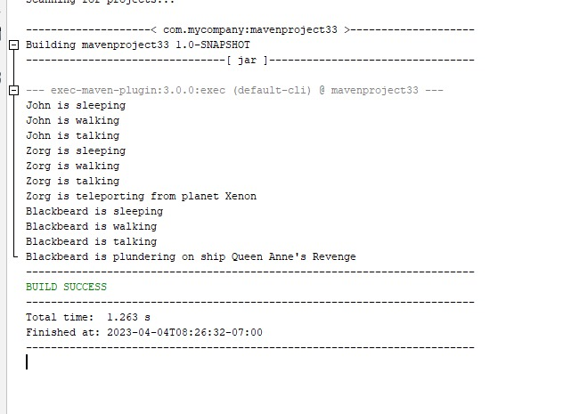

**Task No. 3:**  Write a program that inherits a class named Produce, Cosmetics, Pharmacy, electronic Item and Cloth from a parent class Item. The Item class has its own features like, name and price etc. the Child classes inheriting these functionalities as well as they have their characteristics, thus explaining the concepts of inheritance. Chile classes like Produce, can have their own child classes i.e., Frozen and Fresh.

Solution:

Main Method:

package com.mycompany.mavenproject15;

public class Mavenproject15 {

public static void main(String[] args) {

Fresh Banana = new Fresh("mango",60,"Fruit","29/04/2023");

Frozen Icecream = new Frozen("XYZ", 15, "Ice Cream", "29/04/2023");

Cosmetics cosmetics = new Cosmetics("cream", 3000, "XYZ");

Electronics Laptop = new Electronics("Dell_Latitude", 48000,"Dell");

Pharmacy Painkiller = new Pharmacy("Panadol",50,"GSK");

Cloth cloth = new Cloth("Dress Coat",8000,"Cotton");

System.out.println("Top Products:");

System.out.println("Frozen Product: "+Icecream.getname() +" is of "+Icecream.getCategory()+" category. It costs "+Icecream.getprice()+" and it expires on "+Icecream.getexpirydate());

System.out.println("Fresh Product: "+Banana.getname()+" is of "+Banana.getCategory()+" category. It costs "+Banana.getprice()+" and it expires on "+Banana.getexpirydate());

System.out.println("Cosmetics item: "+cosmetics.getbrand()+" "+cosmetics.getname()+" costs "+cosmetics.getprice());

System.out.println("Electronics item: "+Laptop.getname()+" manufactured by "+Laptop.getmanufacturer()+" costs "+Laptop.getprice());

System.out.println("Pharmacuetical item: "+Painkiller.getname()+" manufactured by "+Painkiller.getmanufacturer()+" costs "+Painkiller.getprice());

System.out.println("Clothes: "+cloth.getname()+" made of "+cloth.getmaterial()+" costs "+cloth.getprice());

}

}

**Class of Item:**

package com.mycompany.mavenproject15;

public class item {

private String name;

private double price;

protected item(String name, double price) {

this.name = name;

this.price = price; }

protected void setname(String name) {

this.name = name; }

protected String getname() {

return name; }

protected void setprice(double price) {

this.price = price; }

protected double getprice() {

return price;

}

}

**Class of Product:**

package com.mycompany.mavenproject15;

public class Product extends item {

private String category;

protected Product(String name, double price, String category){

super(name,price);

this.category = category; }

protected String getCategory() {

return category; }

protected void setCategory(String category) {

this.category = category; }

}

**Class of Fresh:**

package com.mycompany.mavenproject15;

public class Fresh extends Product {

private String expirydate;

public Fresh(String name, double price, String category, String expirydate) {

super(name, price, category);

this.expirydate = expirydate; }

protected void setexpirydate(String brand) {

this.expirydate = expirydate; }

protected String getexpirydate() {

return expirydate; }

}

**Class of Frozen:**

package com.mycompany.mavenproject15;

public class Frozen extends Product{

private String expirydate;

public Frozen(String name, double price, String category, String expirydate) {

super(name, price, category);

this.expirydate = expirydate; }

protected void setexpirydate(String brand) {

this.expirydate = expirydate; }

protected String getexpirydate() {

return expirydate; }

}

**Class of Pharmacy:**

package com.mycompany.mavenproject15;

public class Pharmacy extends item {

private String manufacturer;

public Pharmacy(String name, double price, String manufacturer) {

super(name,price);

this.manufacturer = manufacturer; }

protected void setmanufacturer(String manufacturer) {

this.manufacturer = manufacturer; }

protected String getmanufacturer() {

return manufacturer; }

}

**Class of Electonics:**

package com.mycompany.mavenproject15;

public class Electronics extends item{

private String manufacturer;

protected Electronics(String name, double price,String manufacturer) {

super(name, price);

this.manufacturer = manufacturer; }

protected void setmanufacturer(String manufacturer) {

this.manufacturer = manufacturer; }

protected String getmanufacturer() {

return manufacturer; }

}

**Class of Cloth:**

package com.mycompany.mavenproject15;

public class Cloth extends item{

private String material;

public Cloth(String name, double price, String material){

super(name,price);

this.material = material; }

protected void setmaterial(String material) {

this.material = material; }

protected String getmaterial() {

return material;

}

}

**Class of Cosmetics:**

package com.mycompany.mavenproject15;

public class Cosmetics extends item {

private String brand;

public Cosmetics(String name, double price, String brand) {

super(name,price);

this.brand = brand; }

protected void setbrand(String brand) {

this.brand = brand; }

protected String getbrand() {

return brand; }

}

**Output:**

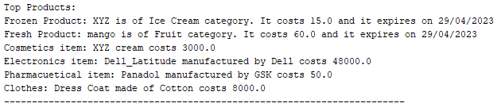

**Task No. 4:** Write a program that inherits a class named Pakistani, BBQ, Chines, Fast Food and Beverages etc. from a parent class Cuisines. The Cuisines class has its own features like, name, quantity, and price etc. the Child classes inheriting these functionalities as well as they have their characteristics, thus explaining the concepts of inheritance. Child classes can have their own child classes.

Solution:

Main Method:

package com.mycompany.mavenproject16;

public class Mavenproject16 {

public static void main(String[] args) {

System.out.println("PAKISTANI: ");

Biryani biryani = new Biryani();

biryani.setname("Biryani");

biryani.setquantity(2);

biryani.setprice(700.0);

biryani.settype("Spicy");

biryani.setmeat("Chicken");

biryani.Display();

Karahi karahi = new Karahi();

karahi.setname("Mutton Karahi");

karahi.setquantity(4);

karahi.setprice(1500.0);

karahi.settype("Mild");

karahi.setspiceLevel("Medium");

karahi.Display();

System.out.println("BBQ:");

BBQ bbq = new BBQ();

bbq.setname("Beef Kabab");

bbq.setquantity(6);

bbq.setprice(800.0);

bbq.setSauce("Mint Chutney");

bbq.Display();

System.out.println("CHINESE:");

Chinies chinese = new Chinies();

chinese.setname("Sweet and Sour Chicken");

chinese.setquantity(4);

chinese.setprice(1200.0);

chinese.setStyle("Cantonese");

chinese.Display();

}

}

**Class of Cuisine:**

package com.mycompany.mavenproject16;

public class Cuisine {

private String name;

private int quantity;

private double price;

protected void setname(String name){

this.name = name;

}

protected void setquantity(int quantity) {

this.quantity = quantity; }

protected void setprice(double price){

this.price = price;

}

protected void display() {

System.out.println("Name: " + name);

System.out.println("Quantity: " + quantity);

System.out.println("Price: " + price); }

}

**Class of Pakistani:**

package com.mycompany.mavenproject16;

public class Pakistani extends Cuisine {

private String type;

protected void settype(String type){

this.type = type;

}

public void Display() {

super.display();

System.out.println("Type: "+type); }

}

**Class of Biryani:**

package com.mycompany.mavenproject16;

public class Biryani extends Pakistani {

private String meat;

protected void setmeat(String meat) {

this.meat = meat; }

public void Display() {

super.display();

System.out.println("Meat Type: "+meat); }

}

**Class of Karahi:**

package com.mycompany.mavenproject16;

public class Karahi extends Pakistani {

String spiceLevel;

protected void setspiceLevel(String spiceLevel) {

this.spiceLevel = spiceLevel; }

public void Display() {

super.display();

System.out.println("Spice Level: " + spiceLevel); }

}

**Class of BBQ:**

package com.mycompany.mavenproject16;

public class BBQ extends Cuisine {

private String sauce;

protected void setSauce(String sauce) {

this.sauce = sauce; }

public void Display() {

super.display();

System.out.println("Sauce: " + sauce); }

}

**Class of Chinies:**

package com.mycompany.mavenproject16;

public class Chinies extends Cuisine {

private String style;

protected void setStyle(String style) {

this.style = style; }

public void Display() {

super.display();

System.out.println("Style: " + style); }

}

**Class of FastFood:**

package com.mycompany.mavenproject16;

public class FastFood extends Cuisine{

private String category;

protected void setCategory(String category) {

this.category = category; }

public void Display() {

super.display();

System.out.println("Category: " + category); }

}

**Class of Beverages:**

package com.mycompany.mavenproject16;

public class Beverages extends Cuisine{

private String brand;

public void setBrand(String brand) {

this.brand = brand; }

public void Display() {

super.display();

System.out.println("Brand: " + brand); }

}

**Output:**

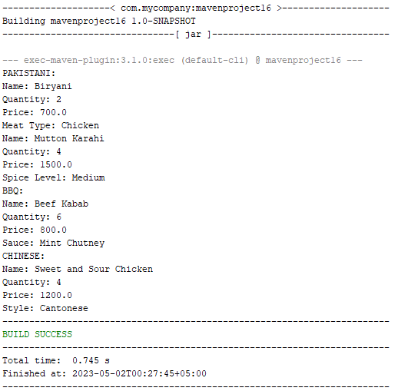

**Task No. 5:** Write code according to given guide.You must draw a class diagram first to start writing your code.

Consider a superclass Items which models customer’s purchases. This class has:

* Two private instance variables name (String) and unitPrice (double).
* One constructor to initialize the instance variables.
* A default constructor to initialize name to “no item”, and unitPrice to 0. use this()
* A method getPrice that returns the unitPrice.
* Accessor and mutator methods.
* A toString method to return the name of the item followed by @ symbol, then the unitPrice.

Consider two subclasses WeighedItem and CountedItem. WeighedItem has an additional instance variable weight (double) in Kg while CountedItem has an additional variable quantity (int) both private.

* Write an appropriate constructor for each of the classes making use of the constructor of the superclass in defining those of the subclasses.
* Override getPrice method that returns the price of the purchasedItem based on its unit price and weight (WeighedItem), or quantity (CountedItem). Make use of getPrice of the superclass
* Override also toString method for each class making use of the toString method of the superclass in defining those of the subclasses.

toString should return something that can be printed on the receipt.

For example

Banana @ 3.00 1.37 Kg 4.11 PKR (in case of WeighedItem class)

Pens @ 4.5 10 units 45 PKR (in case of CountedItem class)

Solution:

Main Method:

package com.mycompany.mavenproject17;

public class Mavenproject17 {

public static void main(String[] args) {

System.out.println("Fruits and vegetable shop:\n");

System.out.println("------------Weighed Item--------------");

WeighedItem w1 = new WeighedItem("Mangoes",200,3.5);

System.out.println("Price of "+w1.getname()+" is "+w1.getprice());

System.out.println(w1.toString());

System.out.println("------------Counted Item--------------");

CountedItem c1 = new CountedItem("Banana",64,6);

System.out.println("Price of "+c1.getname()+" is "+c1.getPrice());

System.out.println(c1.toString()); }

}

Class Of Item:

package com.mycompany.mavenproject17;

public class Items {

private String name;

private double unitprice;

public Items(String name, double unitprice) {

this.name = name;

this.unitprice = unitprice; }

public Items() {

this("no items",0.0); }

protected double getprice() {

return unitprice; }

protected String getname() {

return name; }

protected void setname(String name) {

this.name = name; }

protected void setunitprice(double price) {

this.unitprice = unitprice; }

protected double getunitprice() {

return unitprice; }

public String toString() {

return name+" @ Unitprice:"+ unitprice; }

}

Child Class (WeighedItem):

package com.mycompany.mavenproject17;

public class WeighedItem extends Items {

private double weight;

public WeighedItem(String name,double unitprice, double weight) {

super(name,unitprice);

this.weight = weight; }

public double getprice() {

return super.getprice() *weight; }

public String toString() {

return super.toString()+"(Weight "+weight+" kg)"; } }

Child Class (CountedItem):

package com.mycompany.mavenproject17;

public class CountedItem extends Items {

private int quantity;

public CountedItem(String name, double unitprice, int quantity) {

super(name,unitprice);

this.quantity = quantity; }

public double getPrice() {

return super.getprice() * quantity; }

public String toString() {

return super.toString() + " (Quantity: " + quantity + ")"; }

}

**Output:**

